Customer Stock Management WooCommerce Plugin

1. Install WooCommerce and customer stock management plugin.

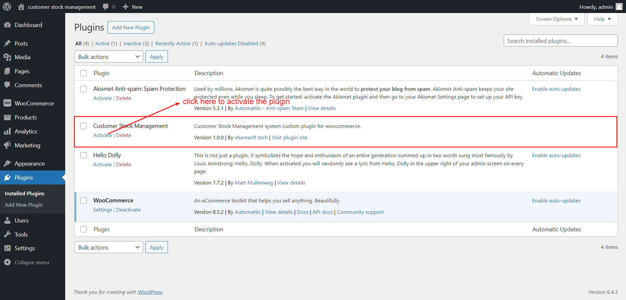

1. After that you can view the plugin added in the list in admin area,

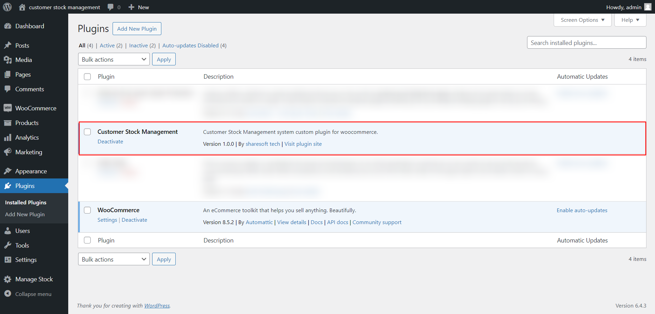

1. After activating Customer Stock Management plugin, After activated that plugin you can see that menu “Manage Stock” & “Create New Role” menu’s in left side bar. Create new role menu should be appears under the User menu.

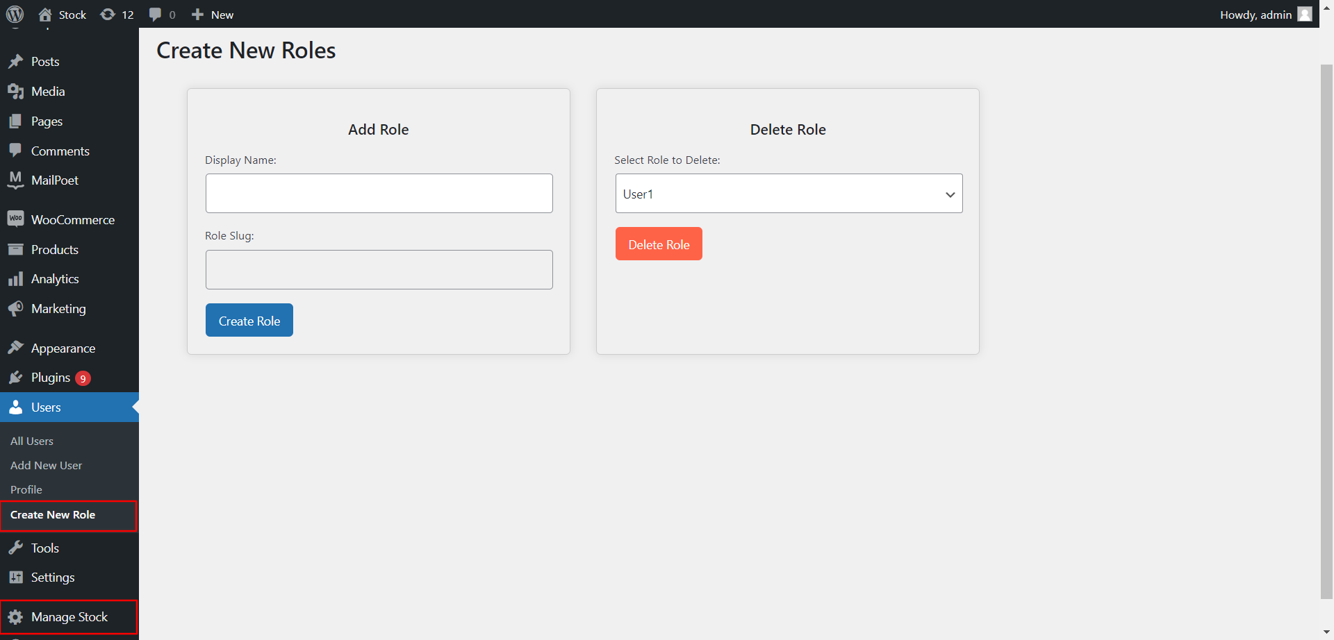

1. Click **Create New Role** to Create a New Role for users.

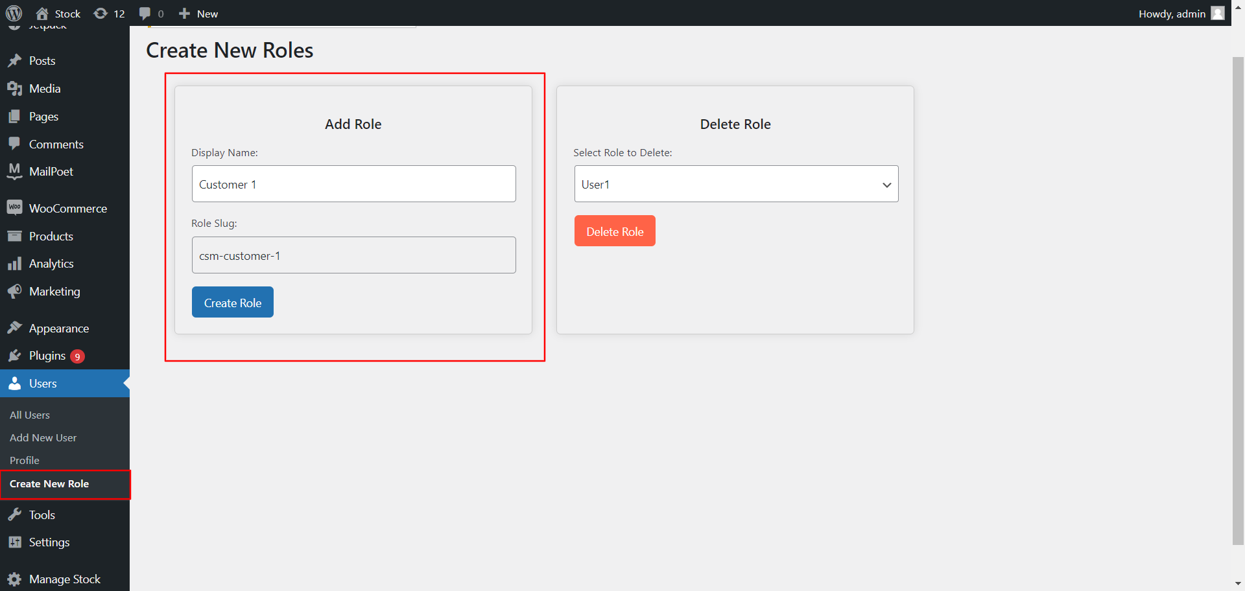

1. If you have to delete the existing created rules you can delete from that listed selected and press “Delete role” button.

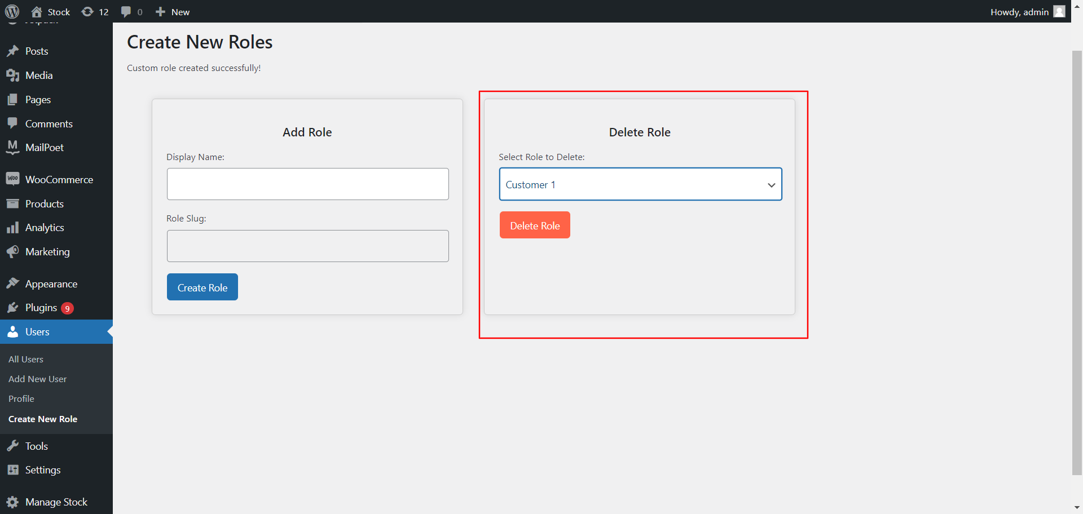

If you need to assign role for existing customer, click on below dropdown with a name role

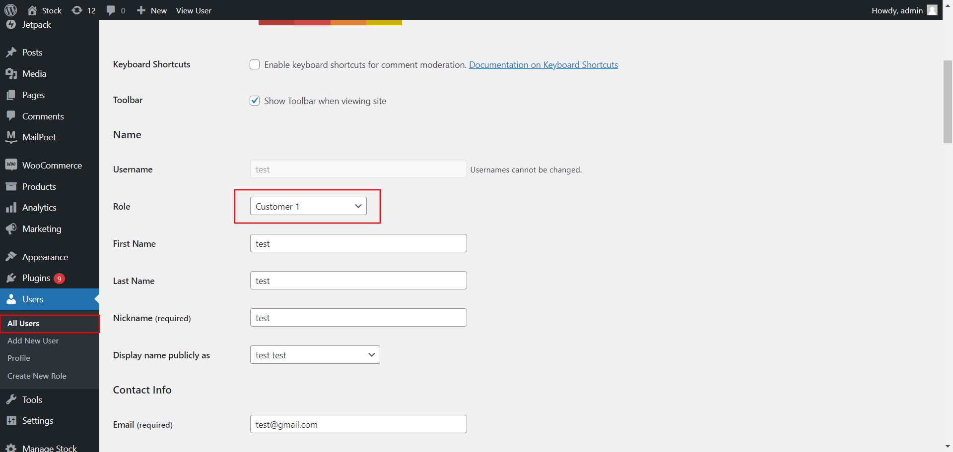

7. Under the product edit section you can see newly added “Product Info” tab for our plugin information.

8. Assign the products to the specific customer role here,

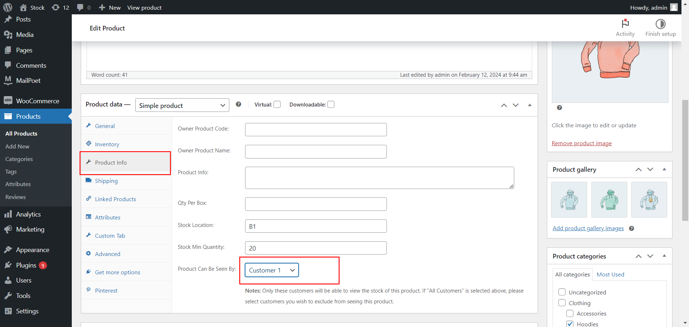

9. If you select ‘All Customers’, Exclude option will be enabled to add exclude customer role group for this products. You can select customers you wish to exclude seeing this product.

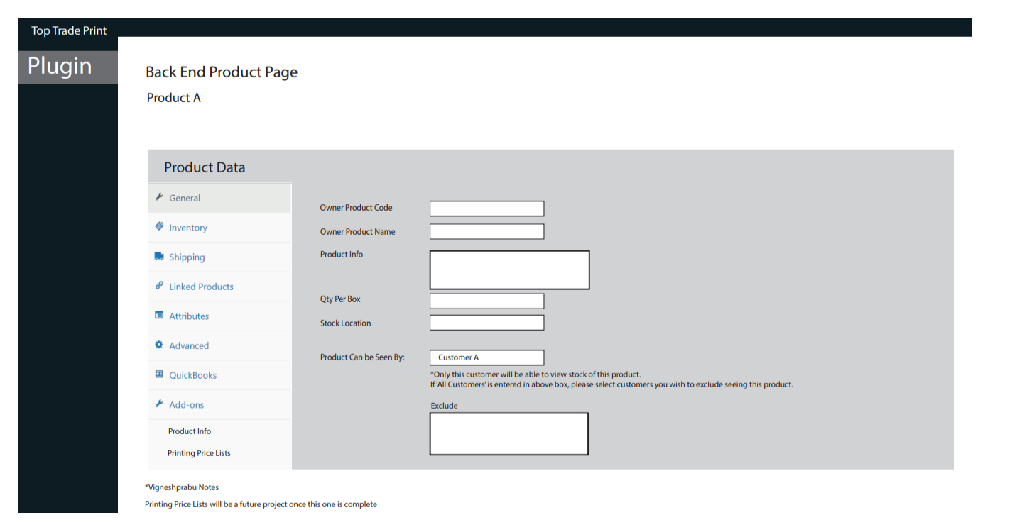

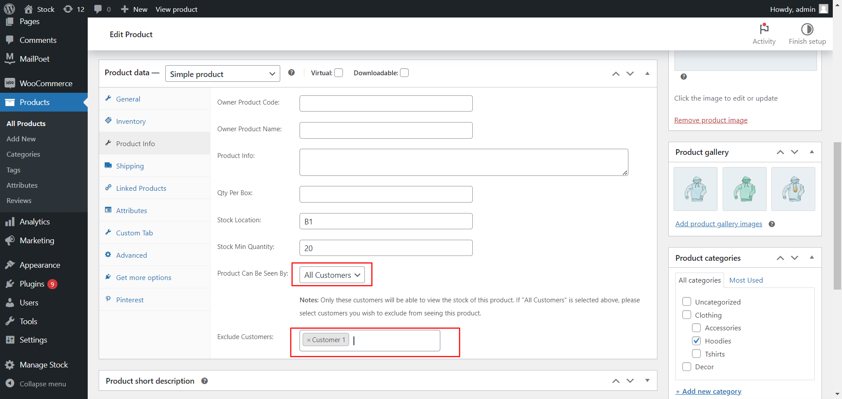

10. Stock log menu page

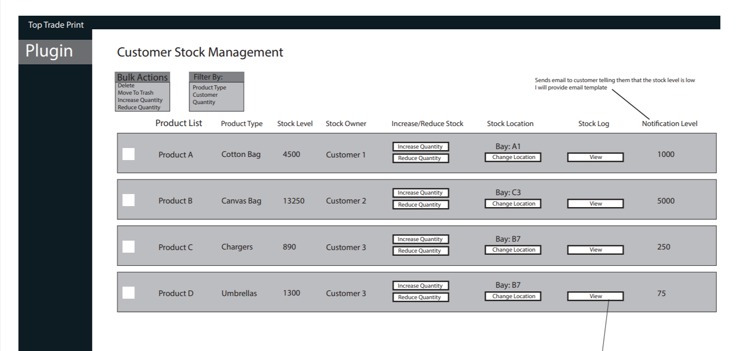

: Click The Manage Stock Menu list for assigned products for all customers role

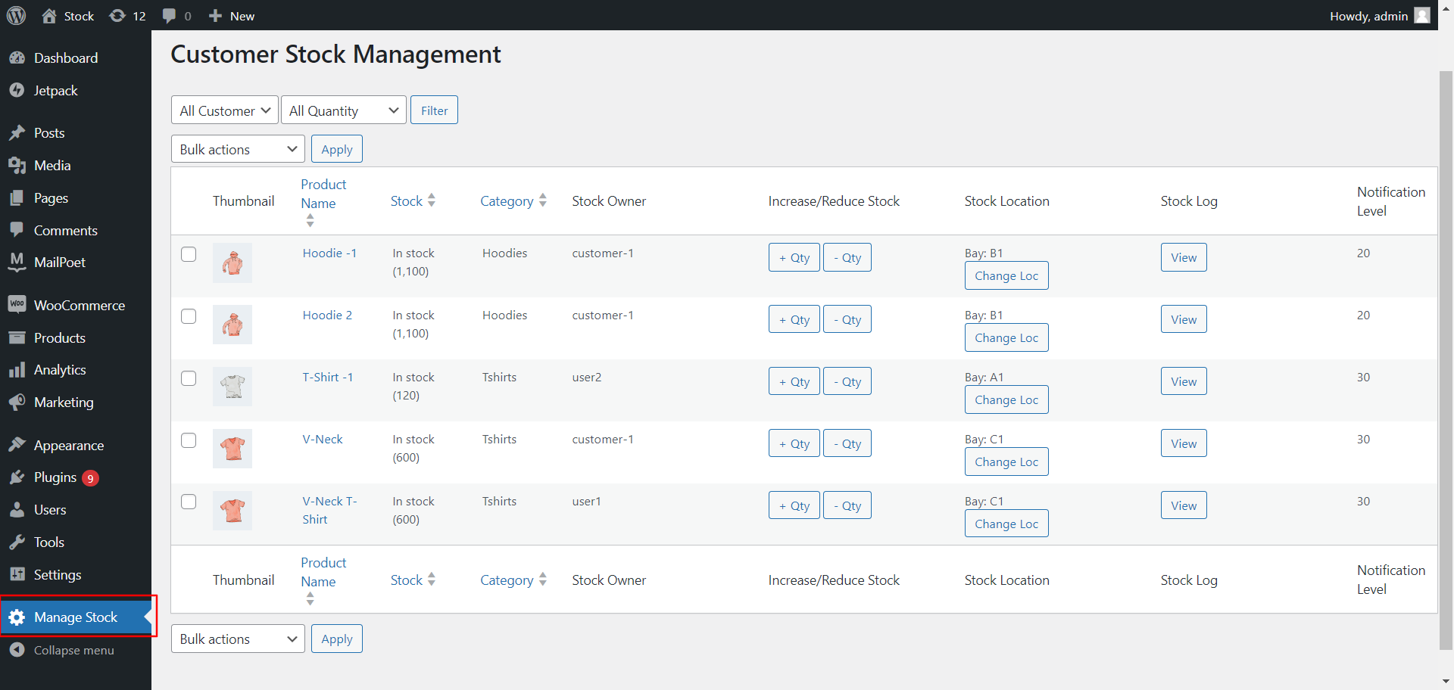

11. If need increase the stock quantity click the **+ Qty** button or reduce the stock quantity click the **– Qty** button**.**

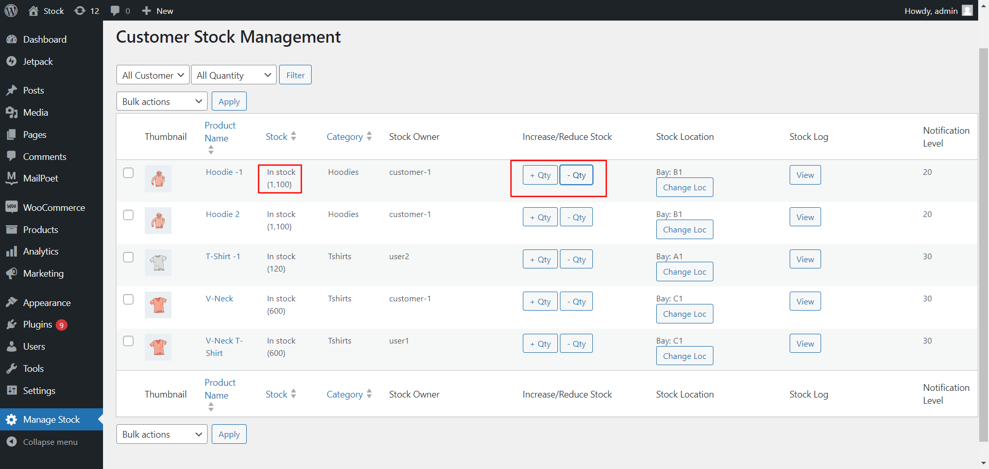

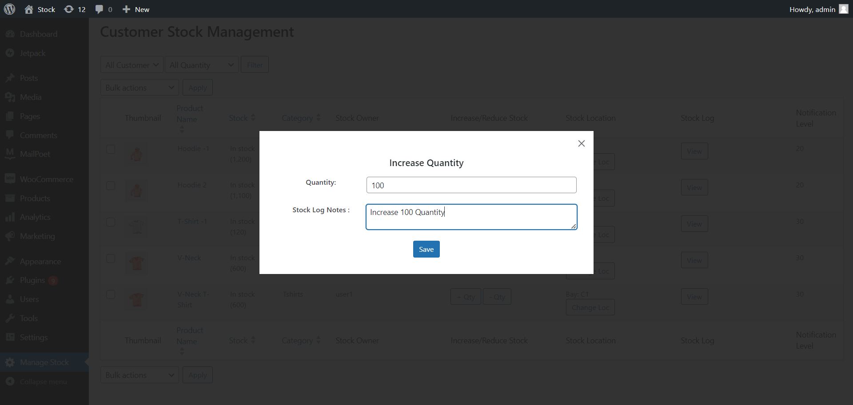

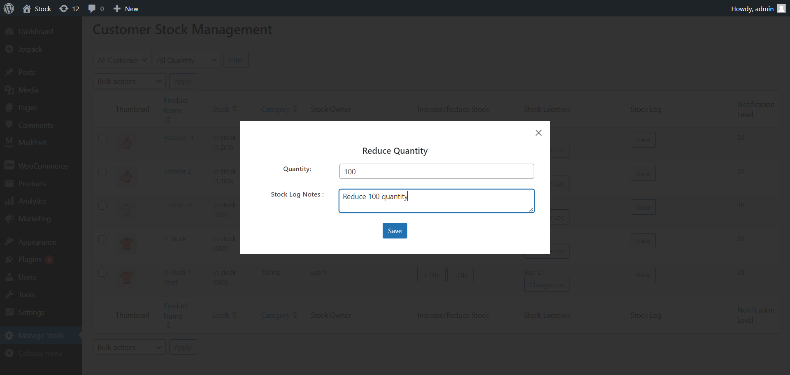

12. Click here to see the stock logs for per Product logs.

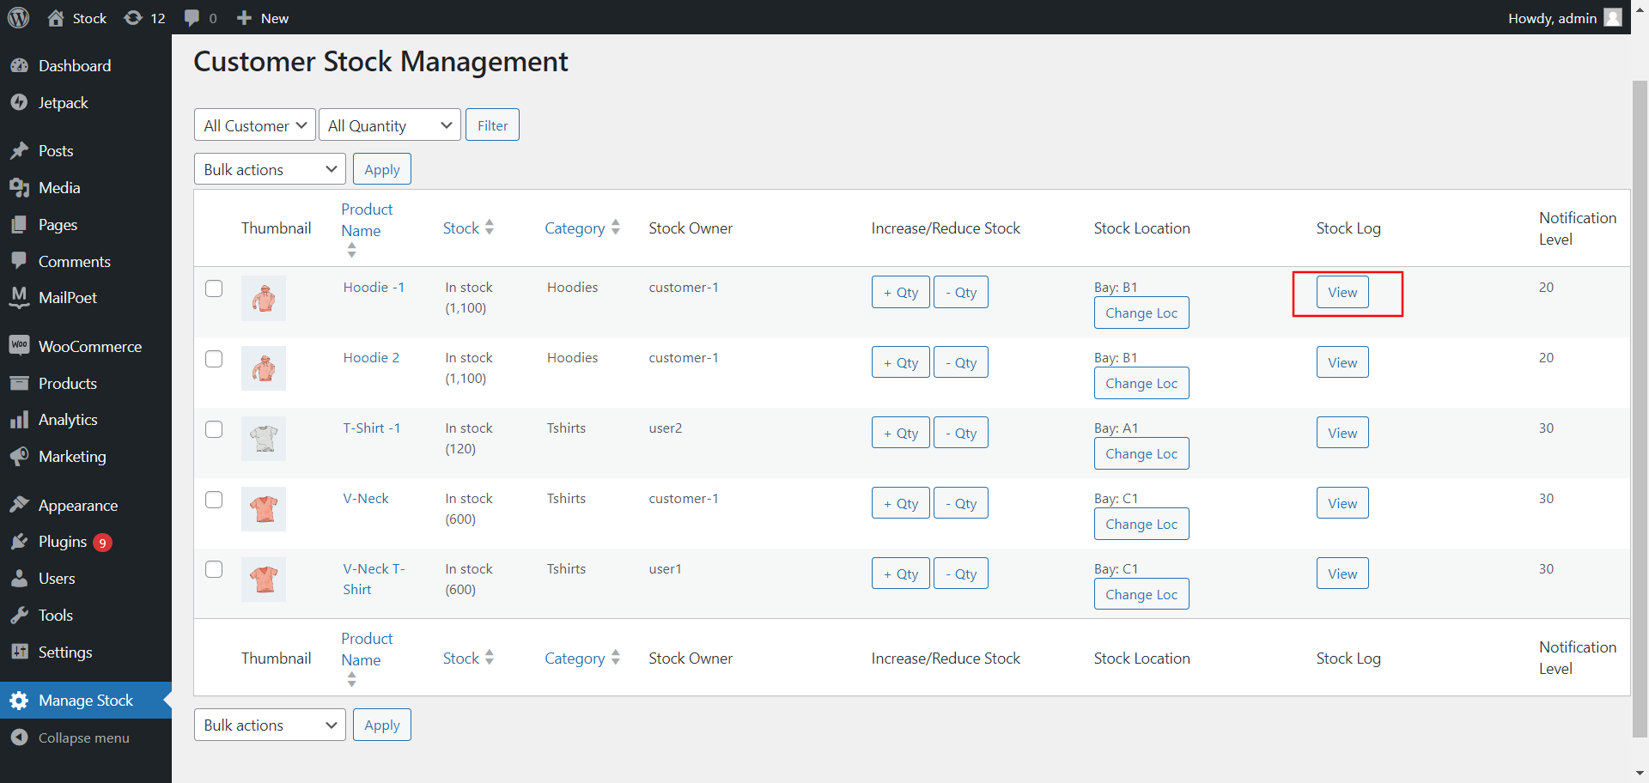

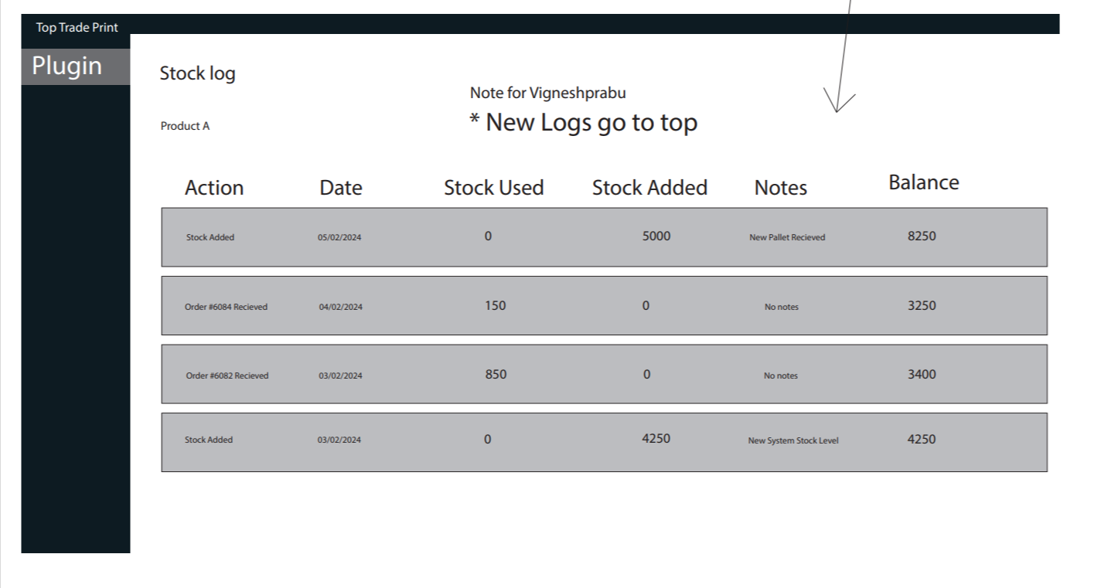

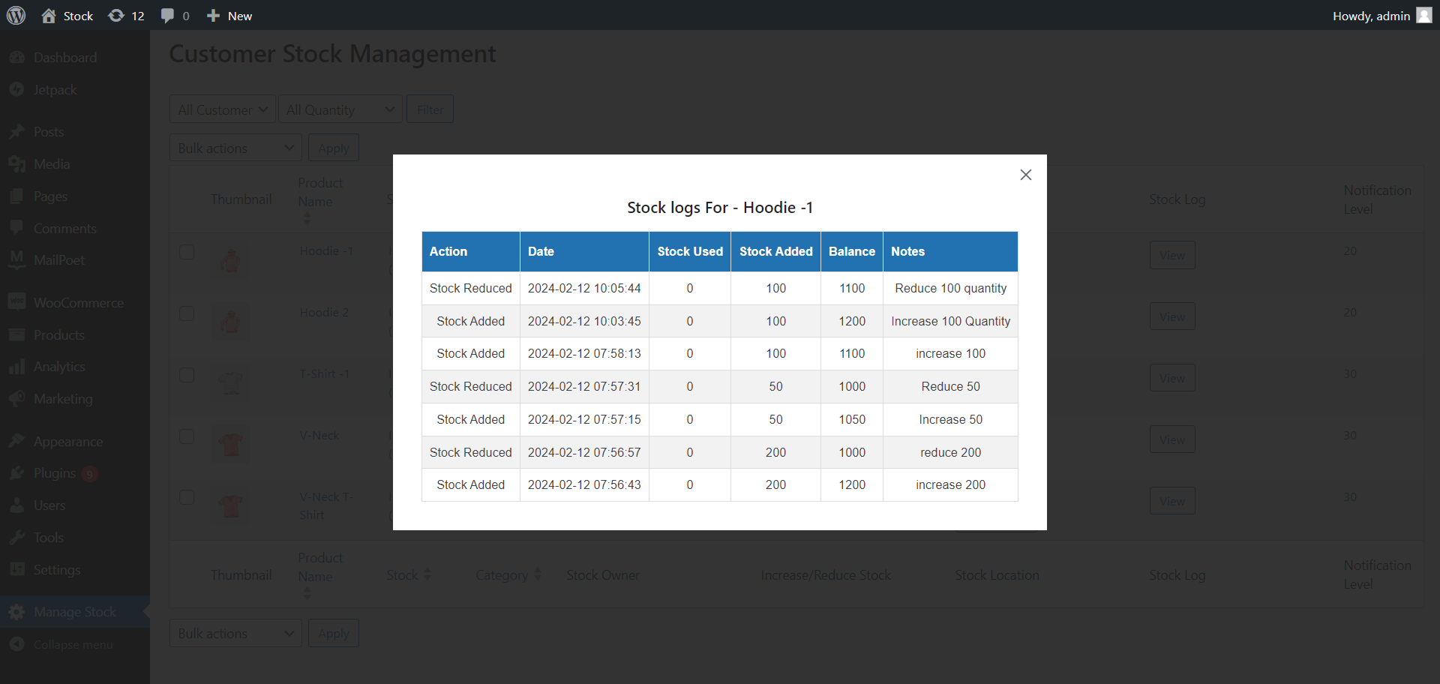

13. Need to change here the Product stock location click to change.

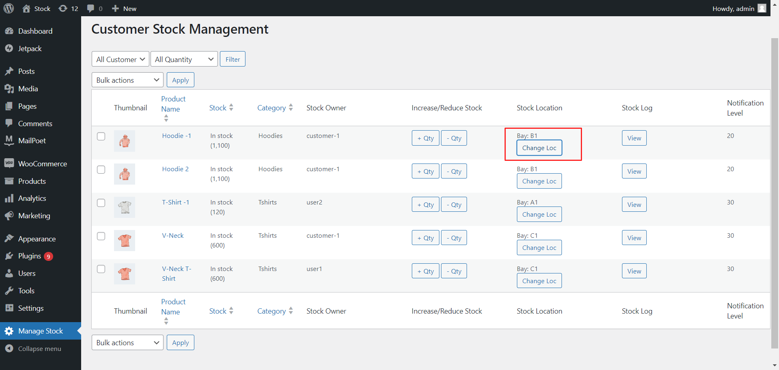

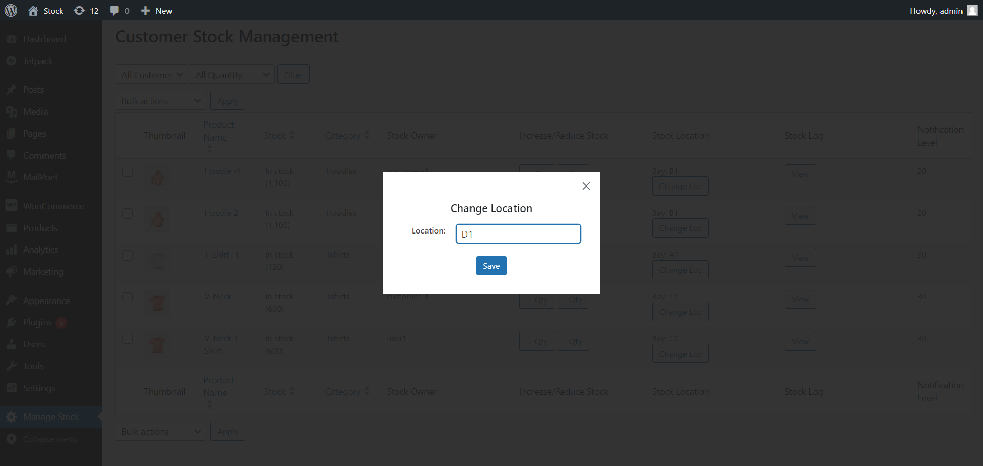

14. Add the Low stock Notification Quantity level, sends email to customer telling them that the stock level is low

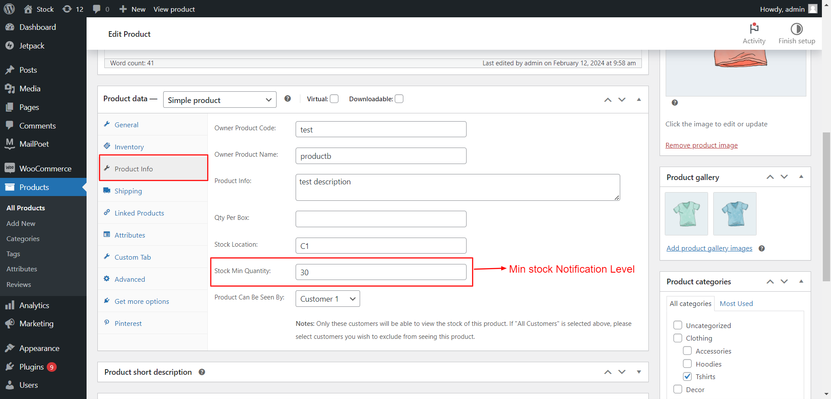

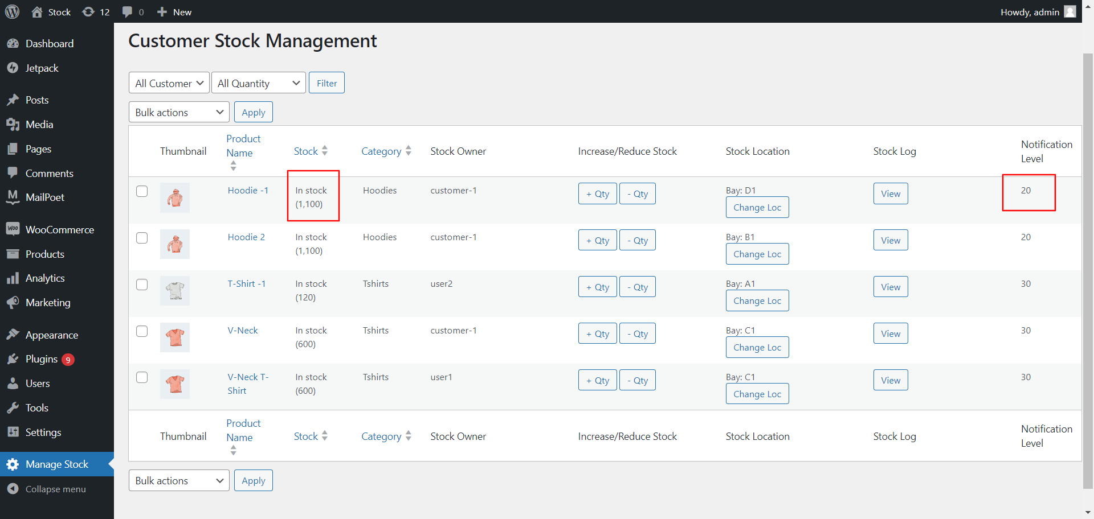

15. Need to Increase the Multiple Products select wanted products then you use the Bulk action select the increase quantity to increased it.

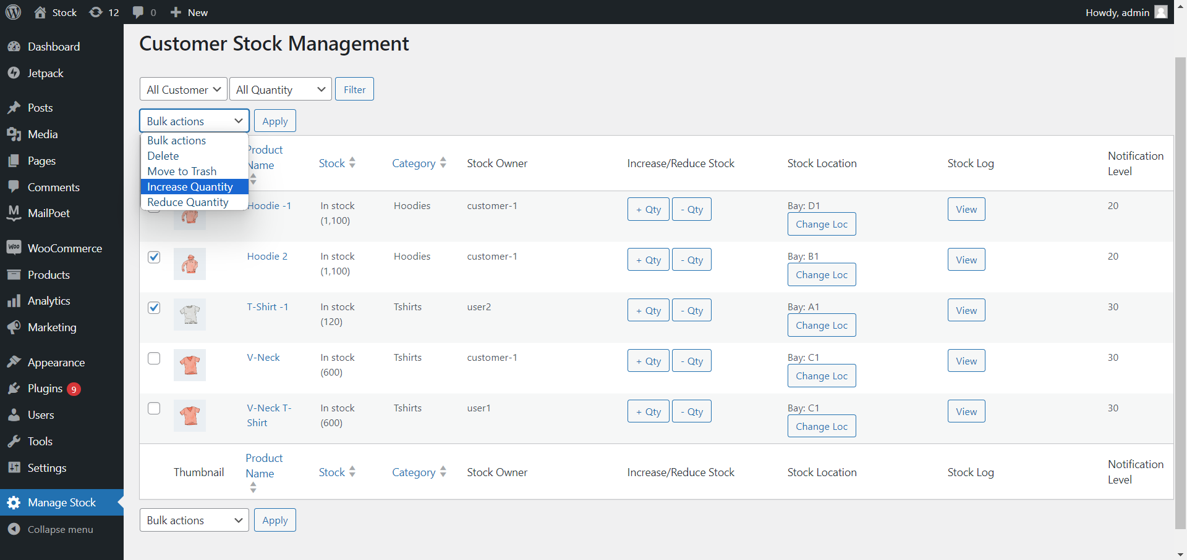

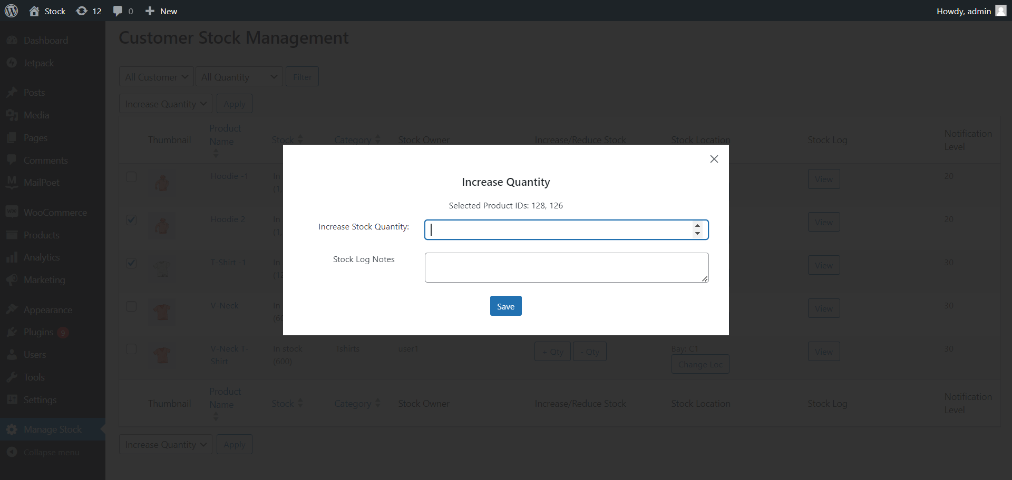

1. Filter by customer roles to display specific customer assigned Products.

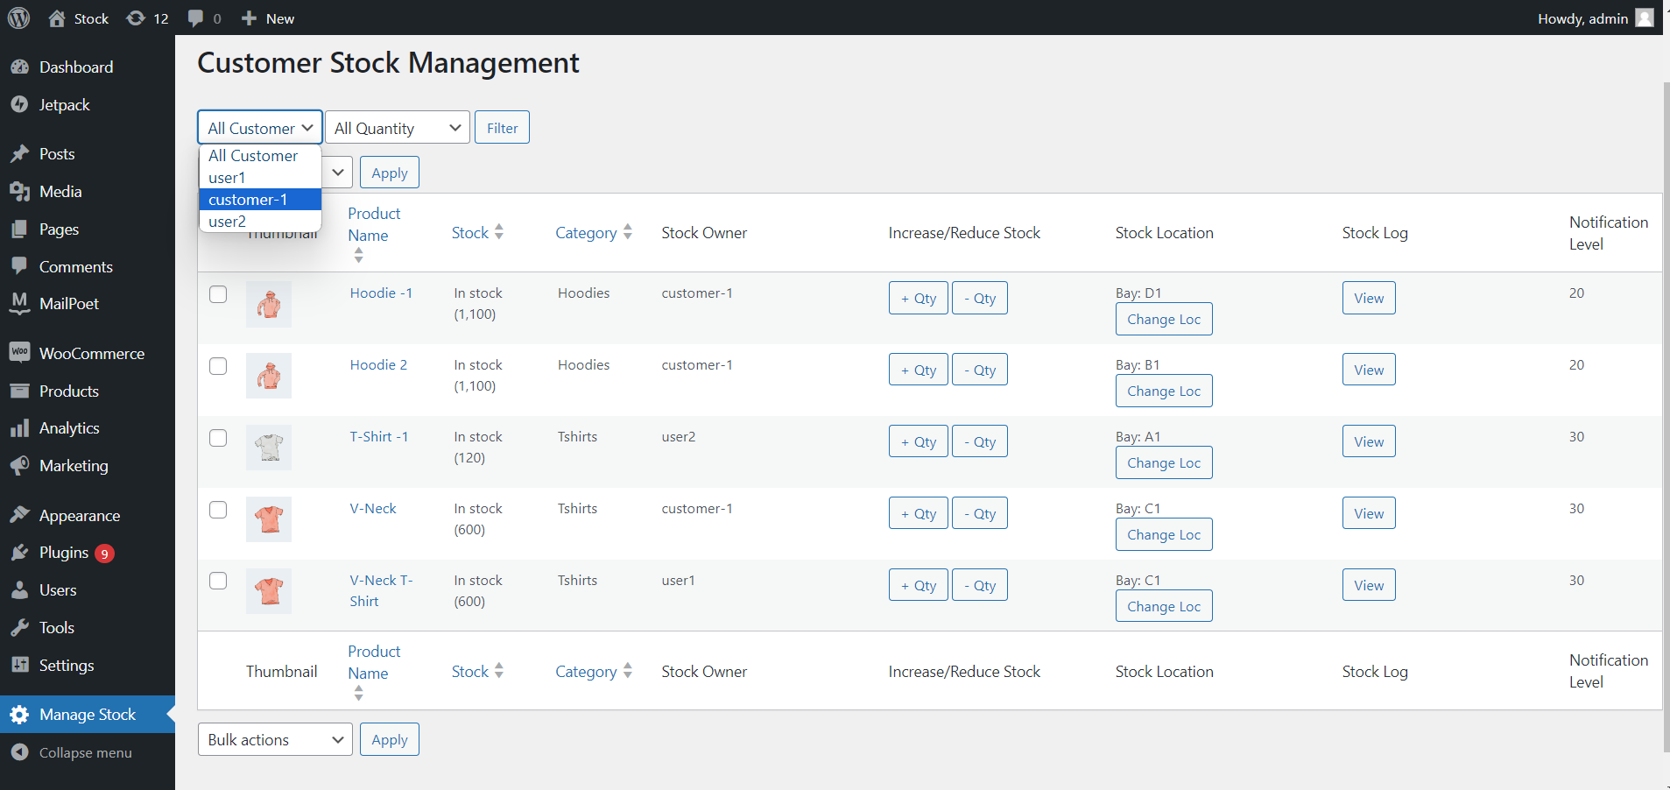

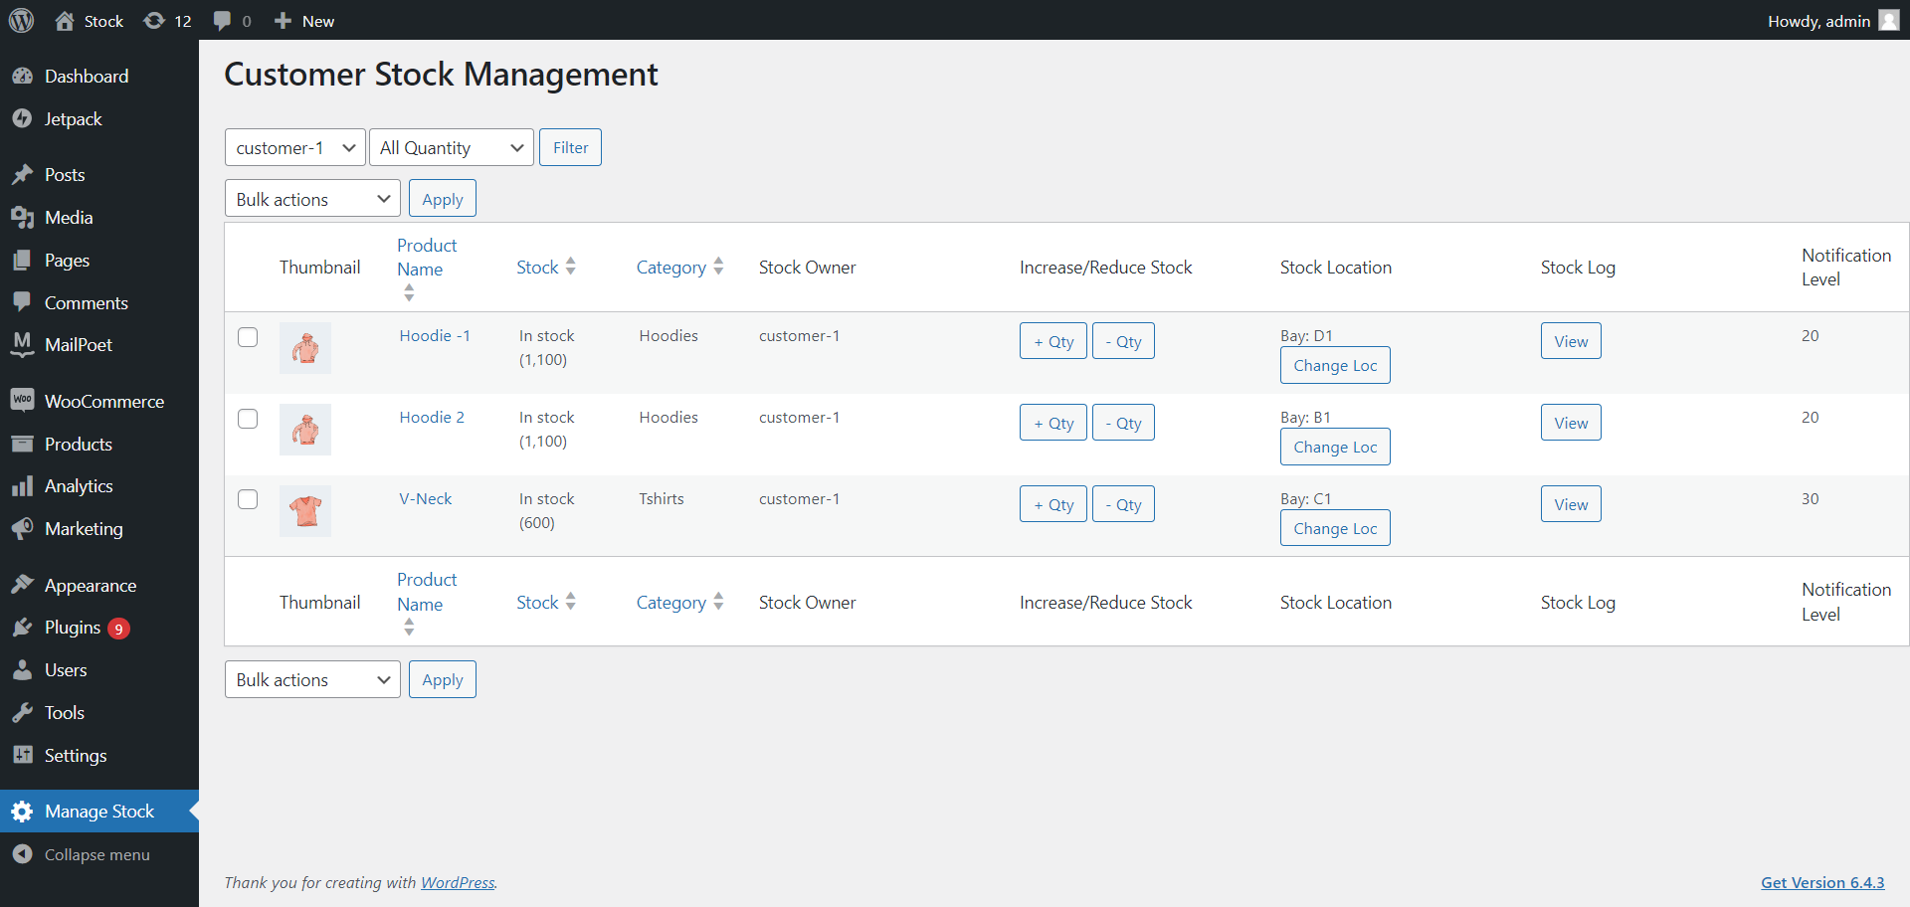

1. Filter by Stock Quantity Ranges to display specific Stock level Products.

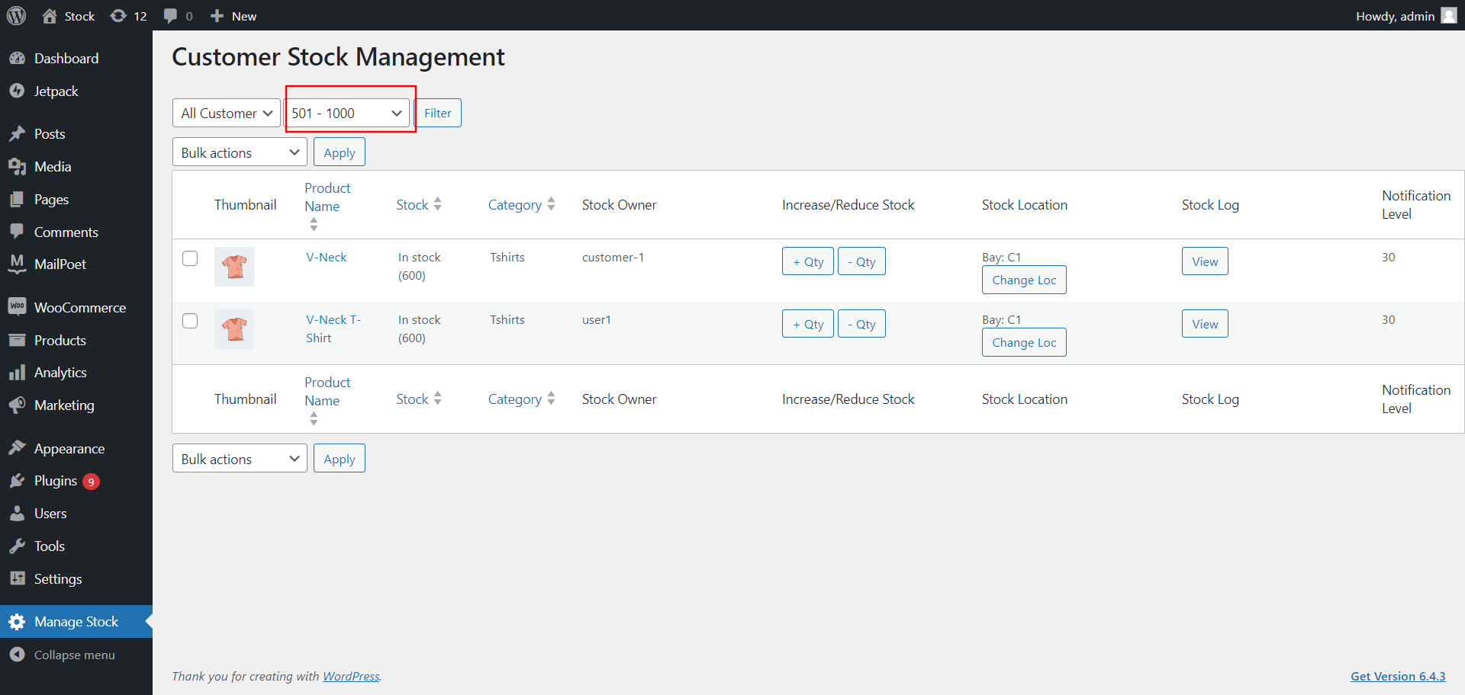

**Front End View**

1. Show The Custom Tab on WordPress My account page **My Stock** click to view that customer Products grid.

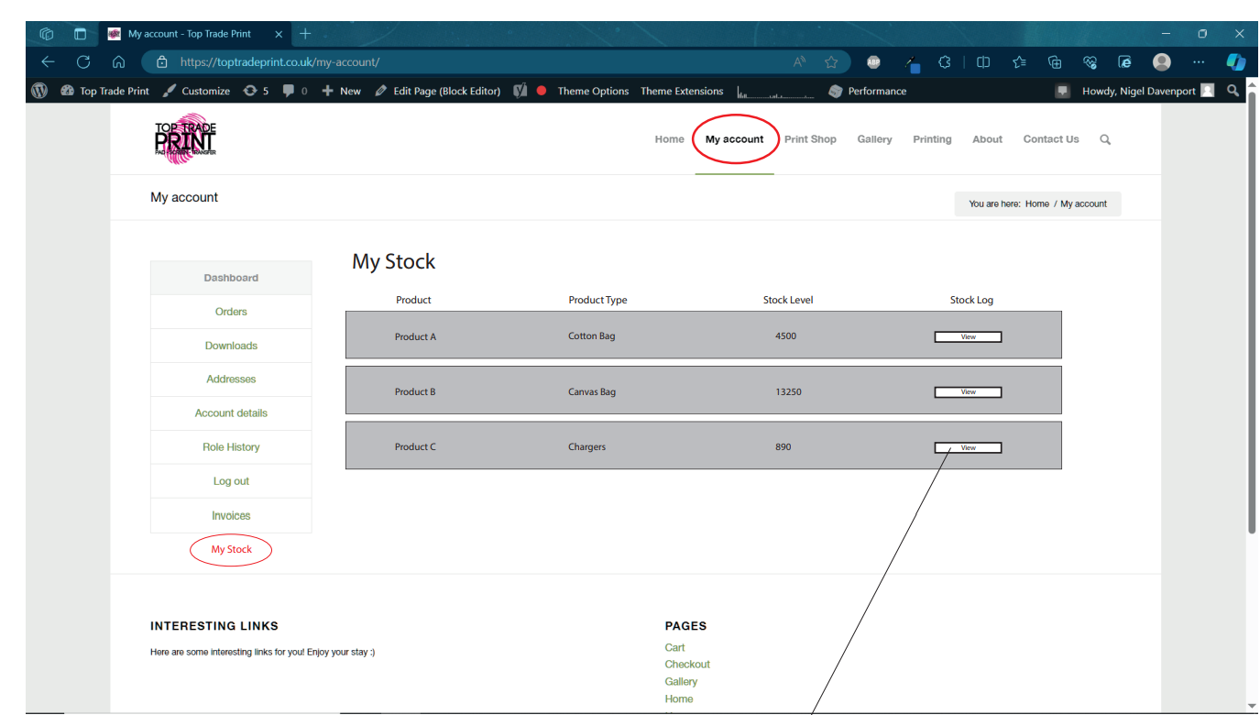

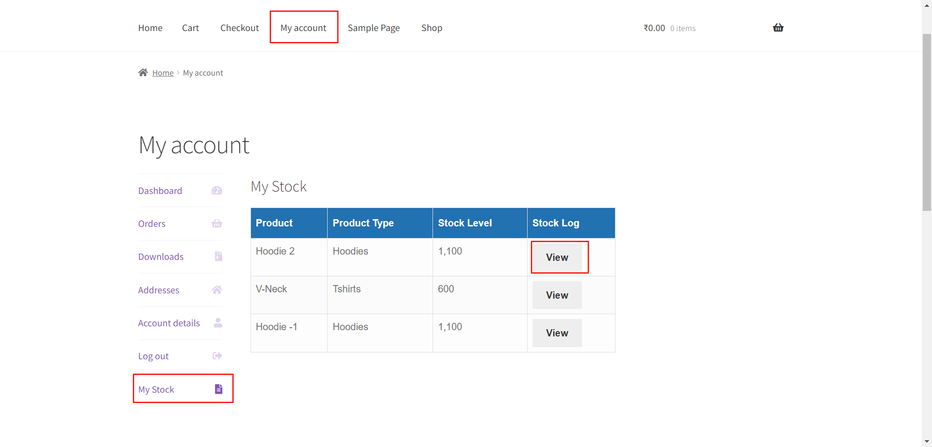

1. Click the View Button to see the specific product stock logs.

